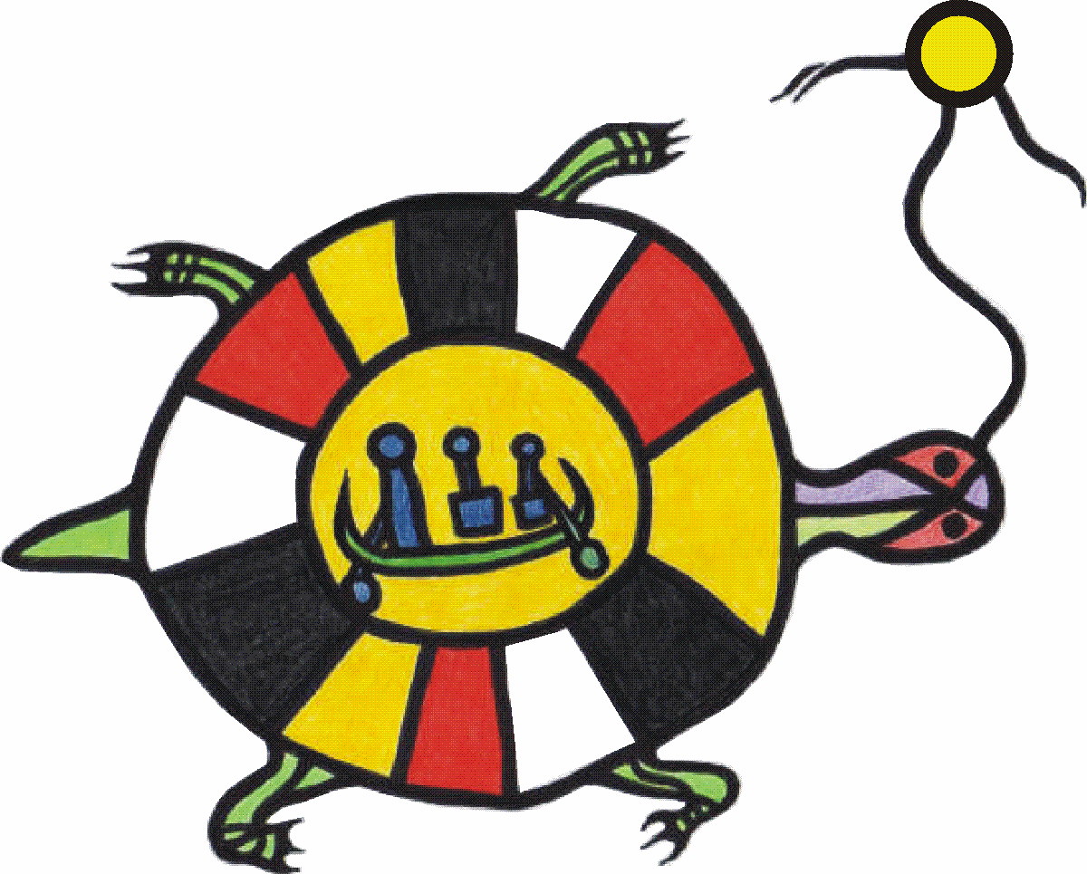 Connecting for Success 

Resources Documents

- Aboriginal Education Advisory Committee Policy
http://www.lakeheadschools.ca/content/media/1738.pdf

- Family Connections – Parent Guide 2/25/2009 - Family Connections Guide Book

- Mentoring – Native Art Video Video shot in NAC101

- Residential Schools – Grade 3 unit of Study Video Heather Harris: Embedding Aboriginal Education

